table of contents

Presented by: tristan weihmann

Shane Ritz

Lynnzee Matthews

Matthew Floyd

Dylan Claywell



Relay Engine

Version [1.0]

Executive summary 2

Summary of Proposal 2

Deliverables 2

Attached Documents/ Files 3

GIT 4

Link to Repository 4

What is GIT? 4

Website Hierarchy 5

Database Entity Relationship Diagram 6

Database Data Dictionary 7

Database SQL Statements 8

Table Creation 8

Data Insertion 9

Executive summary

# Summary of Proposal

Evansville Day School is looking for a web application that will allow them to send text messages to students who sign up for alert lists. We have been given a document outlining the functionality and basic design of the web application. The application requires the use of a database in order to keep track of users, senders, lists, which lists users are subscribed to, and which senders have authorization to send messages to users through the lists. The administrator will have a table in the database which keeps track of and manages how many tokens the senders have for use, the logo image, and the organizations security code.

The Visual Studio project will be hosted on github and will be managed through the git source control method and will be further explained later in the document.

# Deliverables

In this document we will provide a few different deliverables which will highlight the objects designed to complete this web application. The user manual for the application has already been created by the web designers, and will be included in a separate document. The database entity relationship diagram, the website hierarchy, and data dictionary will be included in this document. The SQL statements used to implement the database will be included in this document. The visual studio project will be delivered as a separate attachment, and the github repository link will be provided in this document. The database will be hosted online through Azure.

**THE ADMIN**

**USERNAME = admin**

**PASSWORD = admin**

**Sender**

**EMAIL =** [**euismod.et.commodo@infelis.com**](mailto:euismod.et.commodo@infelis.com)

**PASSWORD = YOURA**

attached Documents/ files

* User Manual : RelayEngine.pdf
* Visual Studio project: CS478-RelayEngine.zip

git

# link to repository

<https://github.com/usiwallaby/CS478-RelayEngine>

# What is git?

Git is a version control method which allows multiple people to make changes to a project at the same time. It keeps track of what changes are made, when the changes are made, and who made the changes. It also allows you to revert to any version of a project if you need to. Github is a website that simply hosts projects and acts as a hub for people to interact with a project using git.

Website Hierarchy

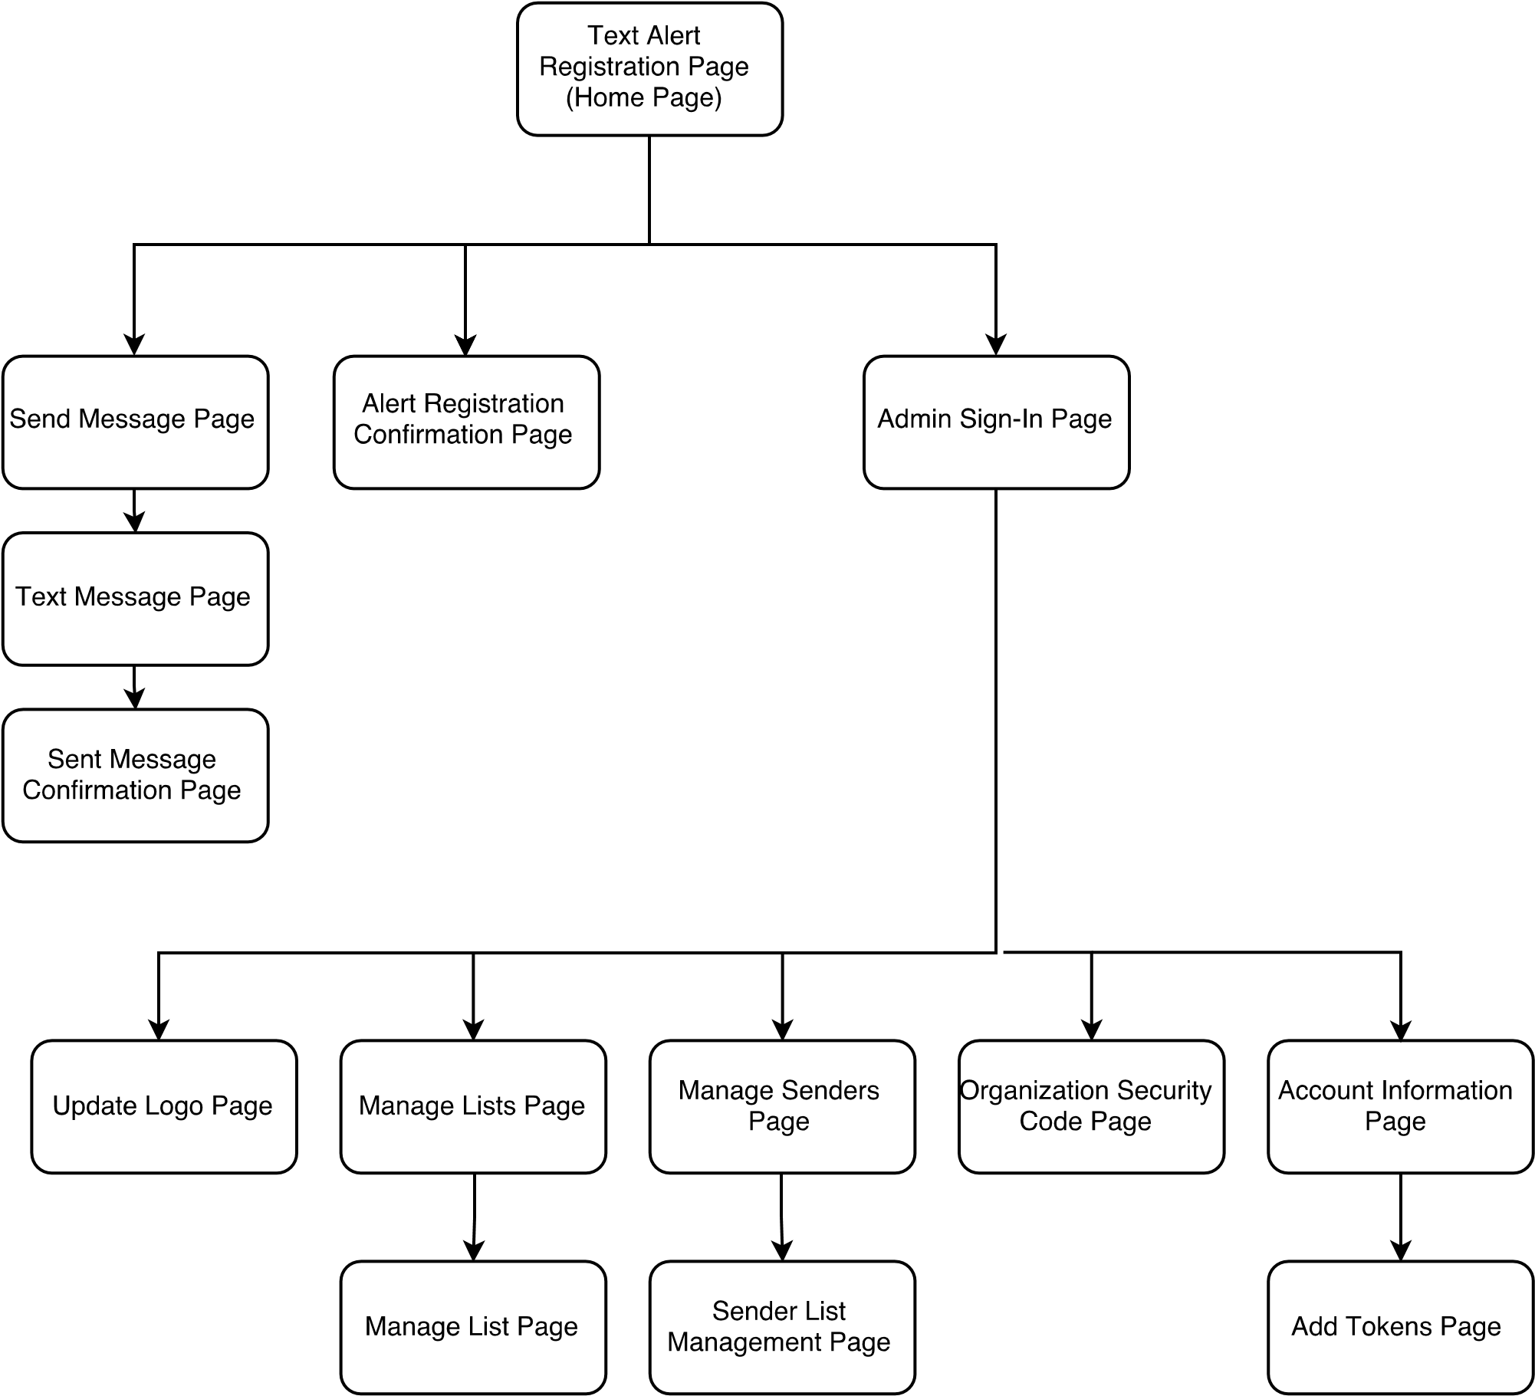

database entity relationship diagram

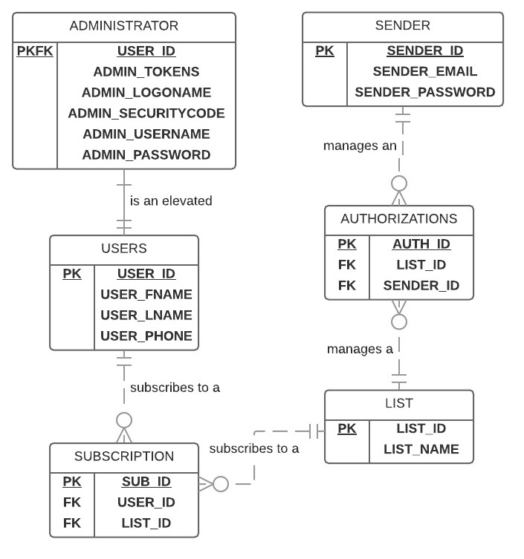

DATABASE DATA DICTIONARY

|  |  |  |  |  |
| --- | --- | --- | --- | --- |
| **Entity** | **Attributes** | **Type/Size** | **Validation** | **Key** |
| ADMINISTRATOR | USER_ID | INT | REQUIRED | PRIMARY/ FOREIGN |
|  | ADMIN_TOKENS | INT | REQUIRED |  |
|  | ADMIN_LOGONAME | VARCHAR(50) | REQUIRED |  |
|  | ADMIN_SECURITYCODE | VARCHAR(50) | REQUIRED |  |
|  | ADMIN_USERNAME | VARCHAR(20) | REQUIRED |  |
|  | ADMIN_PASSWORD | VARCHAR(20) | REQUIRED |  |
| AUTHORIZATIONS | AUTH_ID | INT | REQUIRED | PRIMARY |
|  | LIST_ID | INT | REQUIRED | FOREIGN |
|  | SENDER_ID | INT | REQUIRED | FOREIGN |
| LIST | LIST_ID | INT | REQUIRED | PRIMARY |
|  | LIST_NAME | VARCHAR(50) | REQUIRED |  |
| SENDER | SENDER_ID | INT | REQUIRED | PRIMARY |
|  | SENDER_EMAIL | VARCHAR(30) | REQUIRED |  |
|  | SENDER_PASSWORD | VARCHAR(20) | REQUIRED |  |
| SUBSCRIPTION | SUB_ID | INT | REQUIRED | PRIMARY |
|  | USER_ID | INT | REQUIRED | FOREIGN |
|  | LIST_ID | INT | REQUIRED | FOREIGN |
| USERS | USER_ID | INT | REQUIRED | PRIMARY |
|  | USER_FNAME | VARCHAR(20) | REQUIRED |  |
|  | USER_LNAME | VARCHAR(20) | REQUIRED |  |
|  | USER_PHONE | CHAR(10) | REQUIRED |  |

DATABSE SQL STATEMENTS

# TABLE CREATION

CREATE TABLE USERS(

USER_ID INT UNIQUE NOT NULL,

USER_FNAME VARCHAR(20) NOT NULL,

USER_LNAME VARCHAR(20) NOT NULL,

USER_PHONE CHAR(10) NOT NULL,

PRIMARY KEY (USER_ID)

);

CREATE TABLE ADMINISTRATOR(

USER_ID INT UNIQUE NOT NULL,

ADMIN_TOKENS INT NOT NULL,

ADMIN_LOGONAME VARCHAR(50) NOT NULL,

ADMIN_SECURITYCODE VARCHAR(50) NOT NULL,

PRIMARY KEY (USER_ID),

FOREIGN KEY (USER_ID) REFERENCES USERS(USER_ID)

);

CREATE TABLE LIST(

LIST_ID INT UNIQUE NOT NULL,

LIST_NAME VARCHAR(50) NOT NULL,

PRIMARY KEY (LIST_ID)

);

CREATE TABLE SUBSCRIPTION(

SUB_ID INT UNIQUE NOT NULL,

USER_ID INT NOT NULL,

LIST_ID INT NOT NULL,

PRIMARY KEY (SUB_ID),

FOREIGN KEY (USER_ID) REFERENCES USERS(USER_ID),

FOREIGN KEY (LIST_ID) REFERENCES LIST(LIST_ID)

);

CREATE TABLE SENDER(

SENDER_ID INT UNIQUE NOT NULL,

SENDER_EMAIL VARCHAR(30) NOT NULL,

PRIMARY KEY (SENDER_ID)

);

CREATE TABLE AUTHORIZATIONS(

AUTH_ID INT UNIQUE NOT NULL,

LIST_ID INT NOT NULL,

SENDER_ID INT NOT NULL,

PRIMARY KEY (AUTH_ID),

FOREIGN KEY (LIST_ID) REFERENCES LIST(LIST_ID),

FOREIGN KEY (SENDER_ID) REFERENCES SENDER(SENDER_ID)

);

# DATA INSERTION

INSERT INTO USERS(USER_ID,USER_FNAME,USER_LNAME,USER_PHONE)

VALUES (0,'Lamar','Rodgers','3281763886'),(1,'Tashya','Griffith','3878693363'),(2,'Echo','Sims','7036598094'),(3,'Cassidy','Mitchell','3728051597'),(4,'Signe','Miles','5353534416'),(5,'Fleur','Henderson','8786273576'),(6,'Juliet','Buck','5562156285'),(7,'Melinda','Melton','4239725073'),(8,'Amir','Tucker','7605313408'),(9,'Lareina','Austin','1311013540'),(10,'Clementine','Beasley','5448144124'),(11,'Alice','Figueroa','1979075262'),(12,'Florence','Hardy','9991881621'),(13,'Miranda','Marshall','4355559997'),(14,'Gray','Montoya','9217741224'),(15,'Charlotte','Conley','1757792725'),(16,'Sonya','Wilson','2857899183'),(17,'Mira','Ayers','9991608560'),(18,'Zoe','Strong','4707139747'),(19,'Shea','Osborne','9977149890'),(20,'Chantale','Newton','4516821700'),(21,'Aretha','Cameron','4043331868'),(22,'Ruby','Washington','7509160764'),(23,'Leilani','Jensen','4915654438'),(24,'Ciara','Tucker','6235401497'),(25,'Marcia','Oconnor','4031223907'),(26,'Neve','Key','6093873848'),(27,'Jamalia','Garza','7865590442'),(28,'Todd','Keith','2447028399'),(29,'Tana','Cote','8735517003'),(30,'Conan','Mcdonald','5377350659'),(31,'Kieran','Olson','5808790301'),(32,'Daquan','Guerra','6678879734'),(33,'Evelyn','Singleton','4937834966'),(34,'Elliott','Torres','1677124269'),(35,'Brennan','Graham','4719343621'),(36,'Lillith','Knox','8553662283'),(37,'Maia','Floyd','9636619347'),(38,'Ferris','Holden','3419882142'),(39,'Rigel','Miranda','5971743681'),(40,'Malachi','Faulkner','5164588421'),(41,'Lysandra','Casey','1033034996'),(42,'Xyla','Mcfadden','1702261221'),(43,'Dale','Zimmerman','9298358224'),(44,'Drew','Sanders','9475763890'),(45,'Beverly','Mueller','8936483384'),(46,'Sawyer','Maxwell','4978856158'),(47,'Jillian','Waters','7446029350'),(48,'Sage','Hernandez','9664570556'),(49,'Zeph','Dean','4269191867'),(50,'Barry','Torres','7871059211'),(51,'Whitney','Hood','2095318191'),(52,'Deirdre','Sweet','5966091940'),(53,'Lisandra','Williams','2308050125'),(54,'Orlando','Blevins','8175284733'),(55,'Victoria','Yates','6612132375'),(56,'Portia','Houston','1016319164'),(57,'Petra','Weeks','1076286770'),(58,'Garrett','Freeman','5963925737'),(59,'Meghan','Boyd','4059065995'),(60,'Deborah','Porter','1187213667'),(61,'Leonard','Combs','1418917924'),(62,'Fulton','Noel','1307673549'),(63,'Beatrice','Maxwell','8703776611'),(64,'Deacon','Acevedo','2922112042'),(65,'Mercedes','Ewing','4222743137'),(66,'Raya','Strickland','2848152778'),(67,'Wendy','King','5057335493'),(68,'Donna','Mack','2827489012'),(69,'Laith','Patton','8279138708'),(70,'Jescie','Kelley','6135479892'),(71,'Tiger','Bonner','6546881085'),(72,'Idona','Simpson','4225231902'),(73,'Darrel','Manning','6499675023'),(74,'Aiko','Brennan','6674597016'),(75,'Nadine','Drake','8513947266'),(76,'Indira','Keller','8827375121'),(77,'Salvador','Barrera','3064789405'),(78,'Shay','Mills','8009740504'),(79,'Imani','Black','6749266112'),(80,'Ila','Vazquez','6143501236'),(81,'Graiden','Finch','8751436360'),(82,'Avram','Garza','8362202002'),(83,'Maggie','Crawford','8402112243'),(84,'Demetria','Dejesus','9768326045'),(85,'Libby','Gibson','4378619705'),(86,'Calvin','Donaldson','6076403272'),(87,'Shoshana','Evans','8847418917'),(88,'Ivor','Mccoy','2095363905'),(89,'Germane','Callahan','5341719792'),(90,'Elvis','Sharp','5575492929'),(91,'Athena','Knapp','1076878726'),(92,'Kamal','Marsh','4539473938'),(93,'Steel','Farrell','6553867276'),(94,'Madonna','Klein','1882900527'),(95,'Steven','Levine','6621665468'),(96,'Raymond','Harrington','8447145251'),(97,'Lareina','Gibson','6524984428'),(98,'Michael','Mcgee','4915018818'),(99,'Amy','Stout','9815337379')

;

INSERT INTO LIST(LIST_ID,LIST_NAME)

VALUES (0,'School Cancellation/Delays'),(1,'Lower School Sports'),(2,'Upper School Sports'),(3,'Lower School General Announcements'),(4,'Upper School General Announcements')

;

INSERT INTO SUBSCRIPTION(SUB_ID,USER_ID,LIST_ID)

VALUES (0,1,1),(1,2,0),(2,3,3),(3,4,0),(4,5,2),(5,6,4),(6,7,3),(7,8,1),(8,9,2),(9,10,3),(10,11,0),(11,12,3),(12,13,2),(13,14,3),(14,15,2),(15,16,1),(16,17,0),(17,18,4),(18,19,0),(19,20,2)

;

INSERT INTO SENDER(SENDER_ID,SENDER_EMAIL)

VALUES (0,'euismod.et.commodo@infelis.com'),(1,'at.arcu@faucibusorciluctus.com'),(2,'egestas@mus.com'),(3,'enim@ornareegestas.net'),(4,'Maecenas.libero.est@metus.org')

;

INSERT INTO AUTHORIZATIONS(AUTH_ID,LIST_ID,SENDER_ID)

VALUES (0,0,0),(1,1,1),(2,2,2),(3,3,3),(4,4,4)

;

INSERT INTO ADMINISTRATOR(USER_ID,ADMIN_TOKENS,ADMIN_LOGONAME,ADMIN_SECURITYCODE)

VALUES (0,5000,'evansville_day_school.jpg','No Code Set')

;